Hardware Project of ICT

**Blind Walking Stick**

*Submitted by:*

1. M.MUDASSIR (22-cs-91)
2. Ehtisham-Ul-Islam(22-cs-82)

*Submitted to:*

**Dr. Muhammad Munwar Iqbal**

**Department of Computer Science University of Engineering and Technology, Taxila**

**Fall 2023**

** ABSTRACT**

1

The main objective of this project is to develop a Blind Stick for blind people using an Arduino board and an ultrasonic sensor which sense any object in front of it. As technology is advancing so every person in the world should be able to have feasibility to do things. The blind stick project using Arduino and ultrasonic sensor is designed to help visually impaired individuals navigate their surroundings independently. The project utilizes an ultrasonic sensor to detect obstacles in the path of the user and provides feedback through a vibrating motor and a piezoelectric buzzer. The Arduino microcontroller processes the data from the ultrasonic sensor and controls the feedback mechanisms. The blind stick project aims to provide a cost-effective solution for individuals who have difficulty navigating their environment due to visual impairment, allowing them to move around with more confidence and independence. The Arduino blind project is an assistive technology designed to help visually impaired individuals navigate their environment safely and independently. The system uses an Arduino microcontroller, ultrasonic sensors, and a buzzer to detect obstacles and provide auditory feedback to the user. The sensors detect the distance of objects in the user's path, and the buzzer produces different sounds to indicate the proximity of obstacles. The project includes a user-friendly interface that allows the user to customize the feedback according to their preferences. The Arduino blind project has the potential to improve the quality of life for visually impaired individuals by providing them with a reliable and affordable tool for safe navigation.

|  |  |  |
| --- | --- | --- |
|  |  |  |
|  |  |  |

** ACKNOWLEDGEMENT**

2

Firstly, I want to thank from the core of my heart to Almighty Allah who gave me the blessings in life and lifted me in need and give me firmness, zeal and competence for accomplishment and presentation of this research work.

I also want to put forward Durood on the Holy Prophet Hazrat Muhammad (Peace be Upon Him), who guided us to follow the correct path of Islam and instructed us the vital rules for living the balanced and comprehensive life.

I would like to thank my supervisor Assistant Professor. Dr. Muhammad Munwar Iqbal for providing the proper guidance right way to conduct my research work. He gave me the educational and amiable atmosphere to accomplish this research task in his supervision.

I want to present special thanks to my beloved parents. Who encouraged and helped me throughout life and gave me quality education.

I want to present special thanks to my beloved parents. Who encouraged and helped  
meeducation.  
I would also like to say thanks to my dear sisters and brothers for their endless  
support and their affection. And I would also like to thank my colleagues and dear  
friends who backed and inspired me during my study period.

|  |  |  |
| --- | --- | --- |
|  |  |  |
|  |  |  |

**TABLE OF CONTENTS**

3

1. ABSTRACT ............................................................................................................ ...1

2. ACKNOWLEDGEMENT…………………………………………………………… 2

3. INTRODUCTION ..................................................................................................... ..4

4. PROJECT AIM & SCOPE……………….....................................................................5

5. DESCRIPTION OF PROJEC................................................................................... .....6

6. H/W & S/W REQUIREMENT.......................................................................................7

7. DESCRIPTION OF H/W REQUIRED..........................................................................8

8. INTERFACING OF HC-05 MODULE........................................................................11

9. DESIGN & IMPLEMENTATION...............................................................................13

10. PROS & CONS………………………………………………………………………16

11. APPLICATION..........................................................................................................18

12. FUTURE DEVELOPMENT………………………………………………………..18

13. CONCLUSION…………………….……………………………………………….19

14. REFERENCE……………………………………………………………………….19

|  |  |  |
| --- | --- | --- |
|  |  |  |
|  |  |  |

**Introduction**

4

The blind stick project using Arduino is a device that aims to assist visually impaired individuals in their day-to-day activities by providing them with a safer and more efficient way to navigate through their surroundings.

The project is based on the concept of an electronic stick that is equipped with sensors and microcontrollers to detect obstacles and guide the user through their environment.

The project is designed to help the visually impaired navigate around obstacles such as walls, poles, and other obstructions. The stick uses ultrasonic sensors to detect obstacles and communicates the information to the user through vibrations or sound signals. The stick also has a built-in speaker that can provide audio feedback to the user.

Overall, the blind stick project using Arduino has the potential to improve the quality of life for the visually impaired by providing them with a reliable and effective way to navigate through their environment with greater ease and safety.

The feedback provided by the Arduino can take the form of audio messages or vibrations. For example, if an obstacle is detected within a certain distance, the Arduino can provide an audio message such as "Obstacle detected, please move to the left." The Arduino can also provide vibrations to alert the user to the presence of an obstacle.

Overall, the Arduino blind project is a great example of how technology can be used to improve the lives of individuals with disabilities, and it demonstrates the potential for technology to create a more inclusive and accessible world.

**Project Aim**

5

The aim of the Blind Stick project is to create an electronic device that can assist visually impaired individuals in navigating their surroundings safely and independently. The project involves using an Arduino microcontroller to control a variety of sensors, such as ultrasonic sensors, to detect obstacles and alert the user with audible feedback.

**Project Objective**

* Designing and building a compact and portable device that is easy to use and carry around.
* Integrating ultrasonic sensors to detect obstacles and calculate the distance to them.
* Programming Arduino to convert sensor readings into audible feedback that user can understand and interpret.
* Adding additional features, such as GPS or voice recognition, to further enhance the functionality of the device in future.
* Conducting thorough testing and user trials to ensure that the device is effective, reliable, and meets the needs of visually impaired users.

**Project scope and limitation**



The aim of the Blind Stick project is to create an electronic device that can assist visually impaired individuals in navigating their surroundings safely and independently. The project involves using an Arduino microcontroller to control a variety of sensors, such as ultrasonic sensors, to detect obstacles and alert the user with audible feedback.

|  |  |  |
| --- | --- | --- |
| . |  |  |
|  |  |  |

**Description of the Project**

The blind stick project is designed to assist visually impaired individuals to navigate their surroundings safely. The device uses an Arduino microcontroller and various sensors to detect obstacles in the user's path and provide haptic and auditory feedback to the user.

The components required for this project include an Arduino UNO board, ultrasonic sensor, buzzer, 9V battery supply, and a few other small components like jumper wires and steel Stick.

The stick is equipped with ultrasonic sensors that emit high-frequency sound waves and detect the echo of those waves when they bounce off of objects in the environment. The sensors then calculate the distance to the object based on the time it takes for the sound wave to return.

The ultrasonic sensor data is received by the Arduino microcontroller, which processes the data and determines the distance to the nearest object.

The Arduino also controls the buzzer, based on the sensor data. The buzzer is used to signal important events, such as reaching a predetermined location. It emits a tone that can be heard by the user, even if they are unable to see.

As the obstacle come close to the Arduino Blind stick the beep voice higher ,Initially the voice will low frequency but as we as well as we come to close to the obstacle the frequency of beep become more and more .

|  |  |  |
| --- | --- | --- |
|  |  |  |
|  |  |  |

6

**Hardware Requirement**

7

The list of components mentioned here are specifically for controlling 4 different loads.

1. Arduino Uno.
2. Ultrasonic sensor.
3. 3V DC Buzzer.
4. 9V Battery Power supply.
5. Connecting Wires.
6. Stick / Cane.
7. Arduino Power Supply 5V.
8. Ultrasonic Sensor Power Supply 5V.
9. Tie Clips.

**Software Requirement**

1. Arduino IDE.
2. Ultrasonic sensor library. (For interfacing with ultrasonic sensor)
3. Tone library.

|  |  |  |
| --- | --- | --- |
|  |  |  |
|  |  |  |

**Description of Hardware Required**

8

**Arduino uno**

The Arduino Uno is a microcontroller board based on the ATmega328P. It has 14 digital input/output pins (of which 6 can be used as PWM outputs), 6 analog inputs, a 16 MHz crystal oscillator, a USB connection, a power jack, an ICSP header, and a reset button. It contains everything needed to support the microcontroller; simply connect it to a computer with a USB cable or power it with a AC-to-DC adapter or battery to get started.

The Uno differs from all preceding boards in that it does not use the FTDI USB- to- serial driver chip. Instead, it features the Atmega8U2 programmed as a USB- to- serial converter.

Some Technical Specification of Arduino Uno are:

1. Microcontroller ATmega328P

2. Operating Voltage 5V

3. Input Voltage (recommended) 7-12V

4. Input Voltage (limits) 6-20V

5. Digital I/O Pins 14

6. Analog Input Pins 6

7. DC Current per I/O Pin 40 mA

8. DC Current for 3.3V Pin 50 mA

9. Flash Memory 32 KB of which 0.5 KB used by bootloader

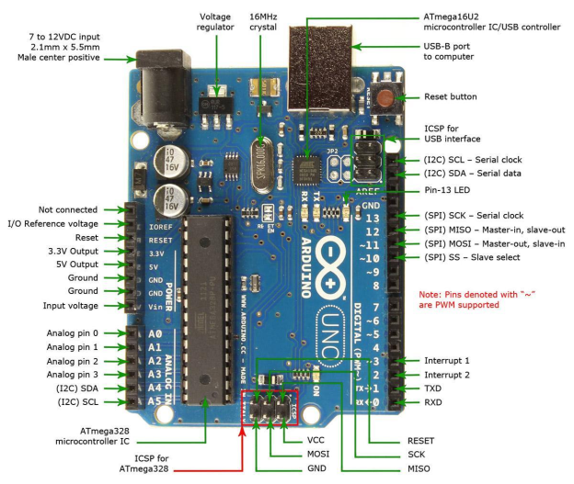**Circuit Diagram**

9

**Figure 01. Circuit diagram for component of Arduino UNO**

**Ultrasonic Sensor**

10

An ultrasonic sensor is a device that uses sound waves with a frequency higher than the human ear can hear (above 20 kHz) to detect the presence and distance of objects. These sensors typically contain a transmitter and a receiver. The transmitter emits ultrasonic waves, which bounce off objects in their path and return to the receiver. The sensor measures the time it takes for the sound waves to travel to the object and return back and uses this information to calculate the distance between the sensor and the object.

Ultrasonic sensors are commonly used in robotics, automation, and other applications where the measurement of distance or the detection of objects is required. They are preferred over other types of sensors in certain applications because they are not affected by colour or texture of the object, and can work in almost any lighting conditions.

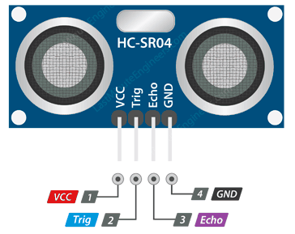

**Figure 02.** Circuit Diagram of Ultrasonic Sensor

|  |  |  |
| --- | --- | --- |
|  |  |  |
|  |  |  |

**3V DC Buzzer**

11

A 3V DC buzzer is an electronic component that produces an audible sound when it receives a direct current (DC) voltage of 3 volts. It typically consists of a small metal or plastic housing with a piezoelectric element inside. When a voltage is applied to the piezoelectric element, it vibrates and produces a sound wave, which can be heard as a tone or beep.

3V DC buzzers are commonly used in electronic circuits and devices as an audible signal for various purposes, such as indicating the completion of a process, warning of an error or malfunction, or alerting to an incoming event. They are compact, low-cost, and easy to use, making them a popular choice for hobbyists and professionals alike.

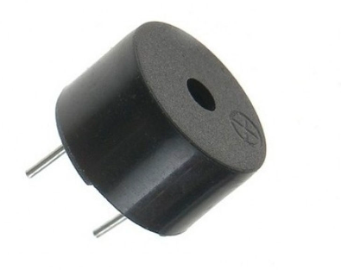

**Figure 03.** 3V DC Buzzer

**Design and Implementation**

1 3

A low cost and efficient smart home system is presented in our design. This system has two main modules: the hardware interface module and the software communication module. At the heart of this system is the Arduino Mega 2560 microcontroller which is also capable of functioning as a micro web server and the interface for all the hardware modules. All communication and controls in this system pass through the microcontroller.

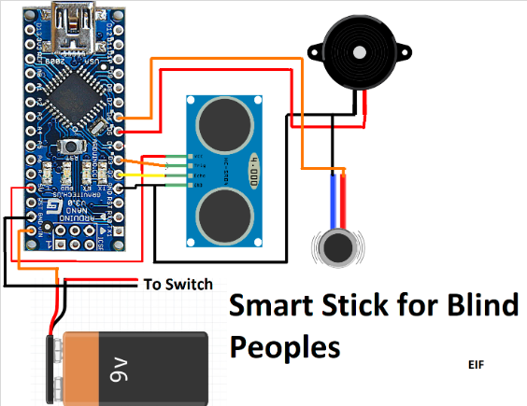**Designing the Circuit**

**Figure 04. Designing the Circuit For Blind Stick**

12

**Technical Specification for this project**

13

**Hardware**

1. Arduino Uno or similar microcontroller board
2. Ultrasonic sensor (HC-SR04 or similar)
3. Buzzer or speaker for audio feedback
4. Vibrating motor for haptic feedback
5. Power source (battery or USB power bank)
6. Casing or enclosure for protection

**Software**

1. Arduino IDE or similar software development environment
2. Programming language: C++
3. Libraries: Ultrasonic, Tone, and Servo (optional)

|  |  |  |
| --- | --- | --- |
|  |  |  |
|  |  |  |

**Program Code**

#include <Ultrasonic.h>

int buzzer = 9;

Ultrasonic ultrasonic(12, 11);

void setup() {

  Serial.begin(9600);

  pinMode(buzzer, OUTPUT);

}

void loop()

{

  int distance = ultrasonic.Ranging(CM);

  if (distance < 50) {

    int dil = 2 * distance;

    digitalWrite(buzzer, HIGH);

//    digitalWrite(led, HIGH);

    delay(dil);

    digitalWrite(buzzer, LOW);

//    digitalWrite(led, LOW);

    delay(dil);}}

14

**Pros of Blind Stick**

15

1. **Cost-Effective**

Using an Arduino board and other electronic components, the blind stick project can be developed at a relatively low cost compared to other available options.

1. **Customizable**

The project can be customized to the needs of the user. For Instance, the sensors and warning systems can be tailored to detect specific obstacles such as curbs, potholes, or steps.

1. **Portal**

The blind stick project can be made compact and lightweight, making it easy for users to carry around**.**

1. **Multifunctional**

The project can be designed to perform multiple functions, including object detection, distance measurement, and obstacle avoidance.

1. **Easy to Use:**

The project can be designed to be user-friendly and intuitive, with simple controls and feedback mechanisms.

|  |  |  |
| --- | --- | --- |
|  |  |  |
|  |  |  |

**Cons of Blind Stick**

16

1. **Limited accuracy**

The accuracy of the sensors used in the project may be limited, leading to false positives or negatives in obstacle detection.

1. **Limited range**

The range of the sensors used may be limited, leading to incomplete detection of obstacles outside the sensor range.

1. **Limited functionality**

The project may not be able to detect all types of obstacles or may have limited capabilities compared to other available options.

1. **Limited reliability**

The project may be less reliable than other options due to the use of inexpensive components or limited testing.

|  |  |  |
| --- | --- | --- |
|  |  |  |
|  |  |  |

**Applications**

17

A blind stick, also known as a white cane, is an important tool used by visually impaired individuals to navigate their surroundings safely and independently. Here are some of the applications of a blind stick:

**Navigation**

The primary use of a blind stick is to help the user navigate their environment. The stick allows the user to detect obstacles, drop-offs, and changes in terrain that they may not be able to see.

**Communication**

A blind stick can also be used as a tool for communication. By tapping the stick on the ground, a blind person can signal to others that they need assistance or alert them to their presence.

**Independence**

A blind stick enables a visually impaired person to move around with greater independence, reducing the need for assistance from others.

**Safety**

Using a blind stick can help prevent accidents and injuries, such as falls or collisions with obstacles.

**Future Development of the project**

**Haptic feedback**

Currently, the blind stick uses audible alerts to warn the user of obstacles. However, future versions could incorporate haptic feedback, such as vibration or pressure, to provide more nuanced alerts.

**Artificial intelligence**

Future versions of the blind stick could incorporate artificial intelligence (AI) to provide more personalized assistance to the user. For example, the device could learn the user's habits and preferences, and adjust its alerts accordingly.

**Incorporating advanced sensors**

The current blind stick uses basic sensors to detect obstacles and alert the user. However, future versions could incorporate more advanced sensors, such as LiDAR or radar, to provide more accurate information about the user's surroundings.

|  |  |  |
| --- | --- | --- |
|  |  |  |
|  |  |  |

18

**Conclusion**

19

In conclusion, the blind stick project using Arduino is a useful device for people with visual impairments. It provides assistance in detecting obstacles and navigating through unfamiliar environments. The project uses ultrasonic sensors to detect obstacles, and a vibration motor to alert the user of their presence.

The implementation of the project requires knowledge of the Arduino platform, programming, and electronics. However, there are many resources available online to guide beginners through the process.

The project can be further improved by adding more sensors or integrating it with other technologies such as GPS or Bluetooth. Additionally, the design of the stick can be made more ergonomic and comfortable for the user.

Overall, the blind stick project using Arduino has the potential to significantly improve the quality of life for people with visual impairments, and is a great example of how technology can be used for social good.

**Reference**

The web sites that provide the information’s:

www.arduinoprojecthub.com

www.makeuseof.com

www.arduinocc.com

www.nstructables.com

www.hackster.com

www.adafruit.com

www.sparkFun.com

|  |  |  |
| --- | --- | --- |
|  |  |  |
|  |  |  |

www.github.com

www.makeuseof.com

www.youtube.com

www.google.com